Name: P V GIRIDHAR
Reg. No: 1972260022
Exercise 4
AIM:
To write a Python program using NumPy arrays and arithmetic operations to calculate the total sales for the year and the percentage increase in sales from the first quarter to the fourth quarter.
ALGORITHM:
Step 1: Start.
Step 2: Import the NumPy library.
Step 3: Create the array sales_data holding the sales amount of Q1, Q2, Q3 and Q4.
Step 4: Calculate the total sales for the year as the sum of all four quarters.
Step 5: Take the first quarter sales as Q1 and the fourth quarter sales as Q4.
Step 6: Calculate the percentage increase = (Q4 - Q1) / Q1 x 100.
Step 7: Display the quarterly sales, the total sales and the percentage increase.
Step 8: Stop.
PROCEDURE:
- Import the NumPy library as np.
- Create the 1-D array sales_data holding the sales amount of the four quarters Q1, Q2, Q3 and Q4.
- Calculate the total sales for the year using np.sum(sales_data).
- Get the first quarter sales using sales_data[0] and the fourth quarter sales using sales_data[3].
- Calculate the percentage increase using the formula (Q4 - Q1) / Q1 x 100.
- Print the quarterly sales, the total sales and the percentage increase.
INPUT AND OUTPUT:
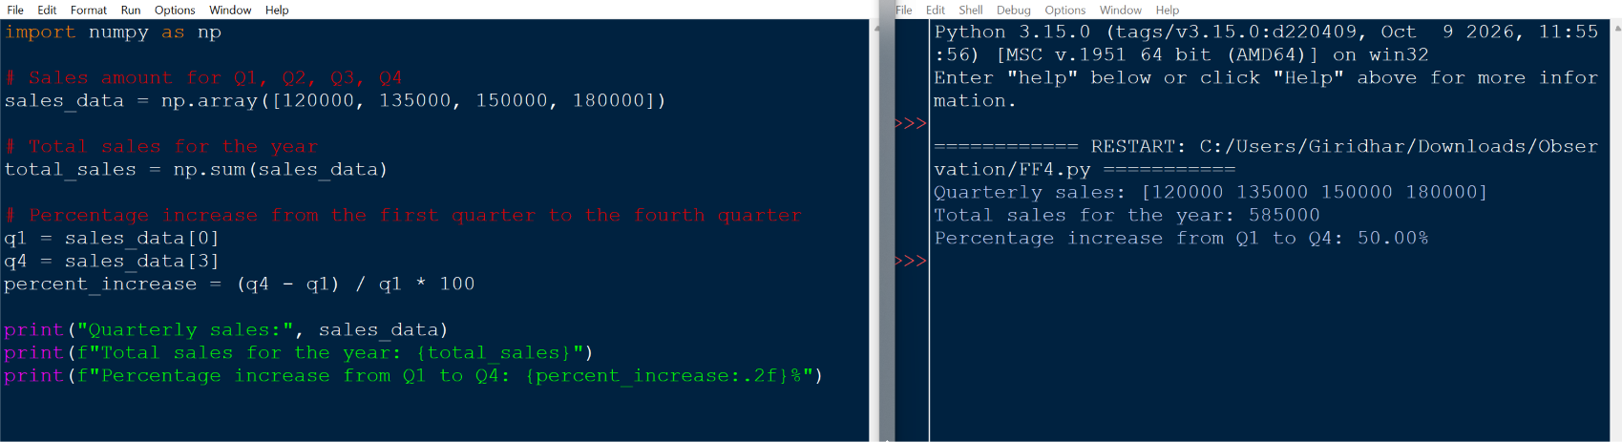
RESULT:
The total sales for the year is 585000 and the percentage increase in sales from the first quarter to the fourth quarter is 50.00%. Thus the program was executed successfully and the output was verified.

